**Steps:**

* + Download project from Git Hub link (https://github.com/san0090/Generate-XML-Code/tree/xml-draw.io-code)
  + Open VS Code & import the project.
  + Click on 'Run' on VS Code menu & click on 'Start Debugging'. Attached screen shot below.

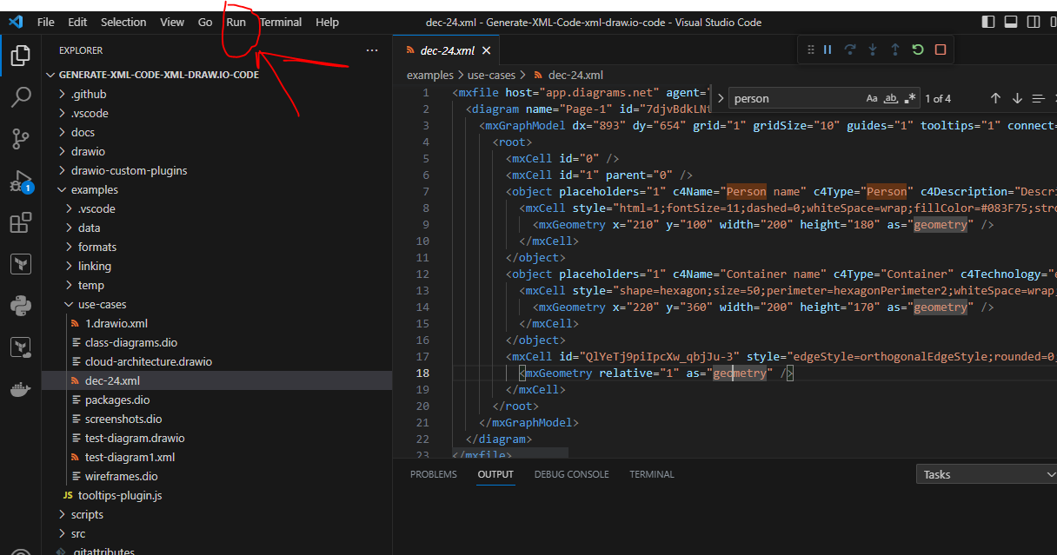

* + Now we can see new separate Draw.io screen & here we need to create any diagram. Click on 'File' -> 'Save as ..' as <file-name.xml> or <file-name.drawio> on draw.io screen. Need to save in 'use-cases' folder where we have downloaded the project.

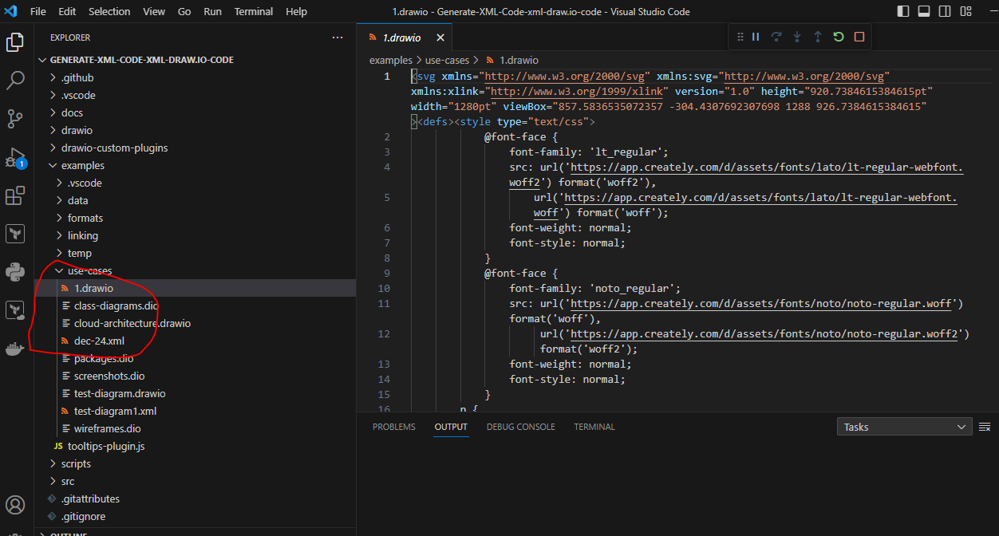

**Example of Generated XML Code**

Here’s a simplified example of what the XML might look like:

<mxfile host="app.diagrams.net" agent="Mozilla/5.0 (Windows NT 6.3; Win64; x64) AppleWebKit/537.36 (KHTML, like Gecko) Chrome/109.0.0.0 Safari/537.36" version="25.0.3">

<diagram name="Page-1" id="7djvBdkLNt2fNOnk0IZ9">

<mxGraphModel dx="893" dy="654" grid="1" gridSize="10" guides="1" tooltips="1" connect="0" arrows="1" fold="1" page="1" pageScale="1" pageWidth="850" pageHeight="1100" math="0" shadow="0">

<root>

<mxCell id="0" />

<mxCell id="1" parent="0" />

<object placeholders="1" c4Name="Person name" c4Type="Person" c4Description="Description of person." label="&lt;font style=&quot;font-size: 16px&quot;&gt;&lt;b&gt;%c4Name%&lt;/b&gt;&lt;/font&gt;&lt;div&gt;[%c4Type%]&lt;/div&gt;&lt;br&gt;&lt;div&gt;&lt;font style=&quot;font-size: 11px&quot;&gt;&lt;font color=&quot;#cccccc&quot;&gt;%c4Description%&lt;/font&gt;&lt;/div&gt;" id="QlYeTj9piIpcXw_qbjJu-1">

<mxCell style="html=1;fontSize=11;dashed=0;whiteSpace=wrap;fillColor=#083F75;strokeColor=#06315C;fontColor=#ffffff;shape=mxgraph.c4.person2;align=center;metaEdit=1;points=[[0.5,0,0],[1,0.5,0],[1,0.75,0],[0.75,1,0],[0.5,1,0],[0.25,1,0],[0,0.75,0],[0,0.5,0]];resizable=0;" parent="1" vertex="1">

<mxGeometry x="210" y="100" width="200" height="180" as="geometry" />

</mxCell>

</object>

<object placeholders="1" c4Name="Container name" c4Type="Container" c4Technology="e.g. Micronaut, etc." c4Description="Description of microservice type container role/responsibility." label="&lt;font style=&quot;font-size: 16px&quot;&gt;&lt;b&gt;%c4Name%&lt;/b&gt;&lt;/font&gt;&lt;div&gt;[%c4Type%:&amp;nbsp;%c4Technology%]&lt;/div&gt;&lt;br&gt;&lt;div&gt;&lt;font style=&quot;font-size: 11px&quot;&gt;&lt;font color=&quot;#E6E6E6&quot;&gt;%c4Description%&lt;/font&gt;&lt;/div&gt;" id="QlYeTj9piIpcXw_qbjJu-2">

<mxCell style="shape=hexagon;size=50;perimeter=hexagonPerimeter2;whiteSpace=wrap;html=1;fixedSize=1;rounded=1;labelBackgroundColor=none;fillColor=#23A2D9;fontSize=12;fontColor=#ffffff;align=center;strokeColor=#0E7DAD;metaEdit=1;points=[[0.5,0,0],[1,0.25,0],[1,0.5,0],[1,0.75,0],[0.5,1,0],[0,0.75,0],[0,0.5,0],[0,0.25,0]];resizable=0;" parent="1" vertex="1">

<mxGeometry x="220" y="360" width="200" height="170" as="geometry" />

</mxCell>

</object>

<mxCell id="QlYeTj9piIpcXw_qbjJu-3" style="edgeStyle=orthogonalEdgeStyle;rounded=0;orthogonalLoop=1;jettySize=auto;html=1;entryX=0.558;entryY=1.017;entryDx=0;entryDy=0;entryPerimeter=0;" parent="1" source="QlYeTj9piIpcXw_qbjJu-2" target="QlYeTj9piIpcXw_qbjJu-1" edge="1">

<mxGeometry relative="1" as="geometry" />

</mxCell>

</root>

</mxGraphModel>

</diagram>

</mxfile>